Type your copy here!

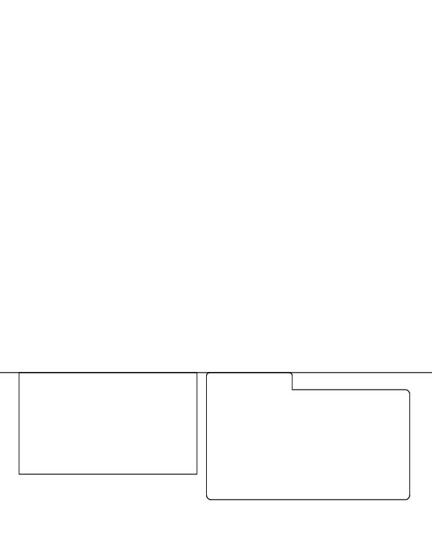
Remember to delete the template prior to printing or the dielines will print on your copy!

